Anatomy of the Adrenal Glands

Learning Objectives

After completing this brick, you will be able to:

* Describe the gross anatomic features and vascular supply of the adrenal gland.
* Describe the different layers of the adrenal cortex and what hormones are produced in each layer.
* Describe the adrenal medulla and what hormones are produced there.

PN is a fellow student who has excelled in her coursework so far. While you are practicing blood pressure readings, you note that hers is 149/94 mm Hg. She confides in you that she is taking the glucocorticoid drug prednisone for an inflammatory kidney disease. You wonder if she could be having a drug side effect and suggest that she visit her regular clinician.

What other possibilities will you and PN discuss that could explain her symptoms? Consider your answer as you read, and we’ll revisit PN at the end of the brick.

What Are the Adrenal Glands?

The adrenal glands are two small, yellowish organs located just above the upper portion (superior pole) of the kidney (Figure 1). Each adrenal gland weighs less than 2 oz, but they are heavyweights when it comes to regulating metabolism, the immune system, blood pressure, and stress responses.

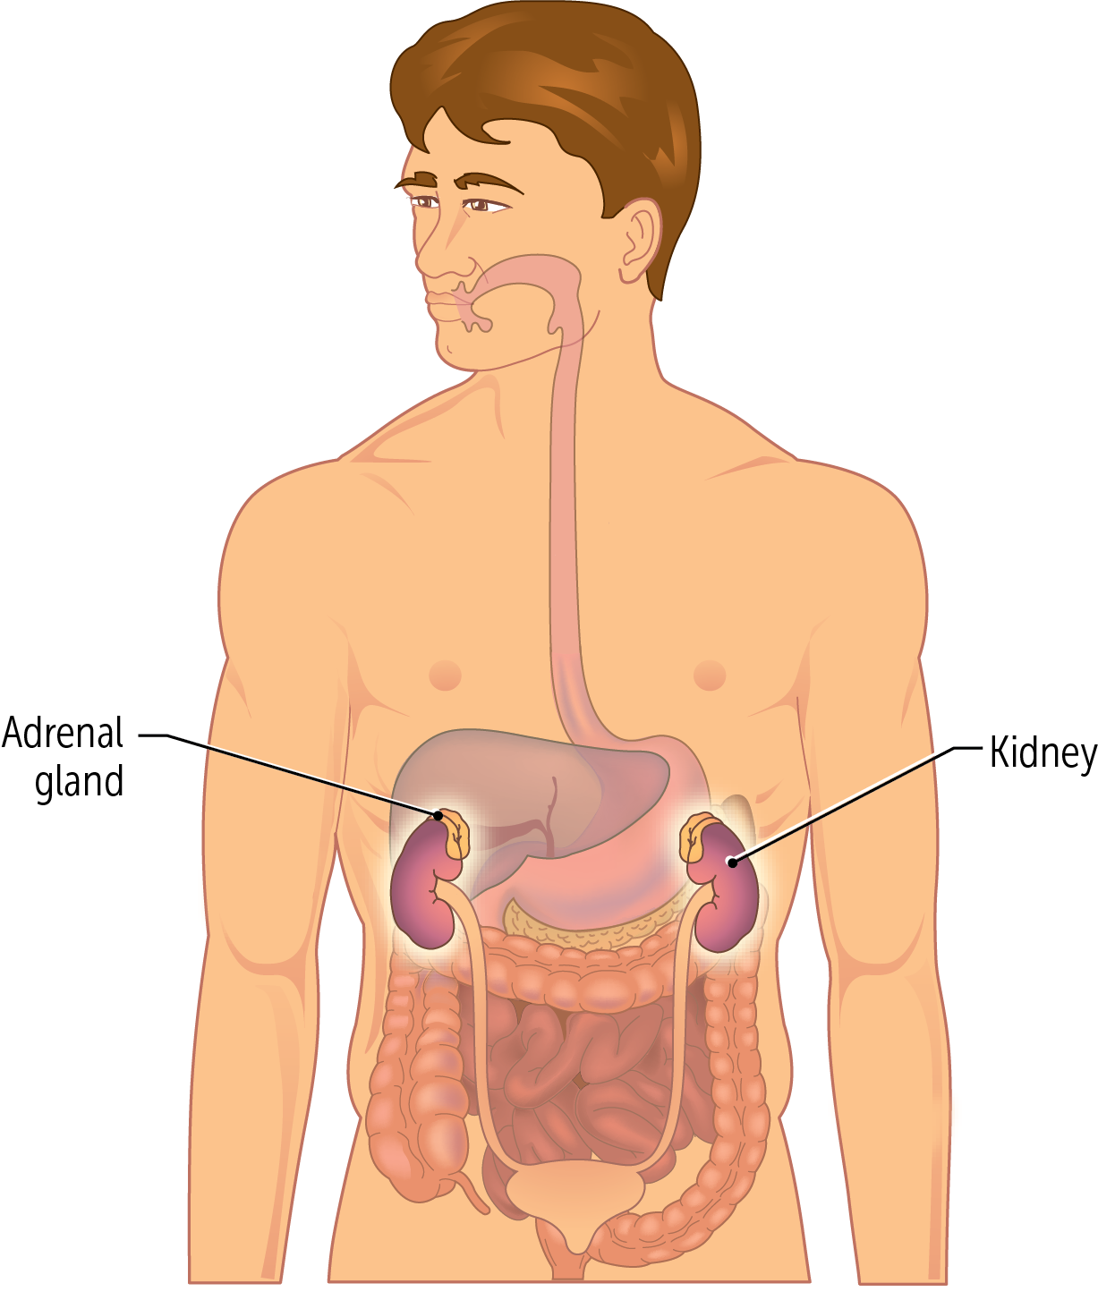

Figure 1

12794

The adrenal glands are separated from the kidneys by the renal capsule and are commonly described as small, triangular “hats” sitting atop the kidney. Like the kidneys, the adrenal glands are retroperitoneal.

Q: Where are the adrenal glands located?

A: The adrenal glands are located just above the superior pole of the kidney.

## Regions

Each adrenal gland has two major regions, the cortex and the medulla, each with different embryonic origins and functions. The entire gland is surrounded by a capsule of connective tissue that overlays the cortex.

The **cortex** appears yellow because of the high concentration of cholesterols used for hormone synthesis. The central area of the adrenal gland is the **medulla**; it is smaller and darker in color (Figure 2).

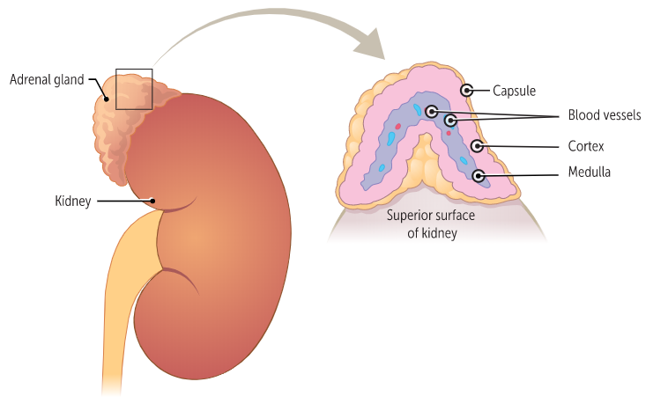

Figure 2

181934

The adrenal **medulla** is in the **middle** of the adrenal gland.

Where is the **m**edulla?

Q: What are the major regions of the adrenal gland?

A: The cortex and the medulla.

## Vascular Supply

What are the major blood vessels that carry blood to and from the adrenal glands? The adrenals receive oxygenated blood from three aptly named arteries (Figure 3): the superior adrenal artery, middle adrenal artery, and the inferior adrenal artery. (The alternate and perhaps more common name for these arteries is the suprarenal arteries).

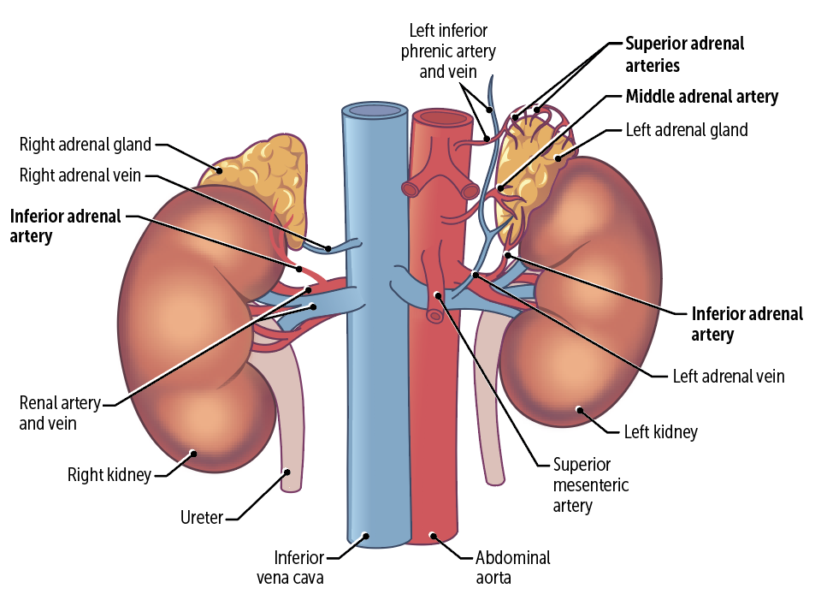

Figure 3

181935

The **superior adrenal artery** is characterized by multiple branches from the inferior phrenic artery. Remember that phrenic goes with diaphragm, which is superior to the adrenal glands, so it makes sense that a phrenic artery gives rise to the superior adrenal artery.

As its name suggests, the **middle adrenal artery** is located between the superior and inferior adrenal arteries; it is a direct branch of the aorta.

The **inferior adrenal artery** originates from the renal arteries, which supply the kidney. The kidneys are inferior to the adrenal glands, so it makes sense that the renal artery gives rise to the inferior adrenal artery!

The venous drainage of the adrenal glands differs by side. The right adrenal gland empties directly into the inferior vena cava via the right adrenal vein. In contrast, theleft adrenal gland empties into the left renal vein via the left adrenal vein.

How Is the Adrenal Cortex Organized?

The adrenal cortex, or outer portion of the adrenal gland, serves several purposes and can be organized on the basis of function, secreted hormones, and histologic appearance.

Functionally**,** the cortex is differentiated into three layers or zones. From external to internal, they are the **zona glomerulosa, zona fasciculata, and the zona reticularis** (Figure 4).

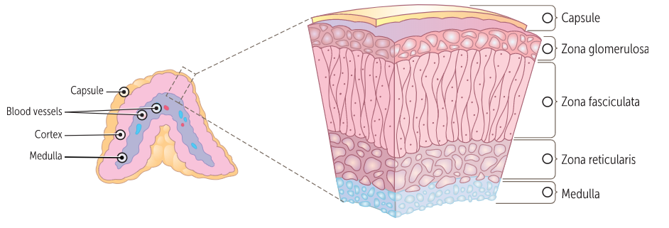

Figure 4

181936

The layers of the adrenal gland from outside to inside can be remembered as **GFR**:  
**G**lomerulosa (external), **F**asciculata (middle), and **R**eticularis (internal)

Layers of the adrenal gland from outside to inside: **GFR**

The cortex is responsible for synthesizing adrenal steroid hormones such as mineralocorticoids, glucocorticoids, and androgens. Each zone produces specific hormones.

## Zona Glomerulosa

The outermost layer of the adrenal cortex is the zona glomerulosa. When we look at an adrenal gland section under the microscope, we can see that the zona glomerulosa is thinner than the other layers. The cells are moderately eosinophilic since they don’t have much lipid in the cytoplasm, and there is an abundance of smooth endoplasmic reticulum (Figure 5).

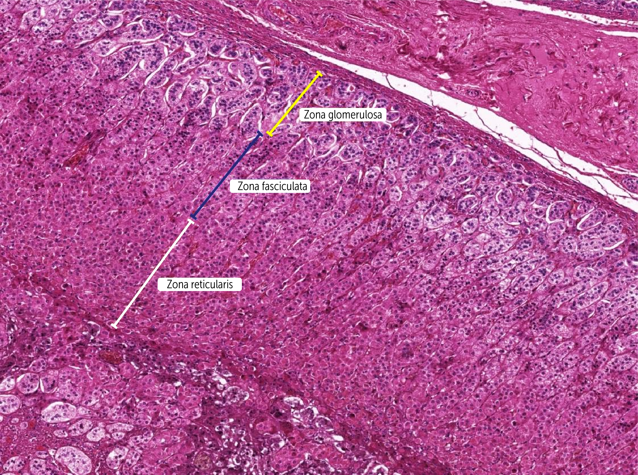

Figure 5

179343

The main job of the zona glomerulosa is the production of **mineralocorticoids**. Mineralocorticoids like aldosterone are essential for renal sodium conservation, potassium excretion, and maintaining blood volume and blood pressure.

## Zona Fasciculata

The next layer is the zona fasciculata, with cells organized in long, radial columns (see Figure 5). This layer produces glucocorticoids such as cortisol and corticosterone. Glucocorticoids help maintain blood pressure, have anti-inflammatory action, and raise blood glucose.

## Zona Reticularis

The innermost is the zona reticularis (see Figure 5). These cells are responsible for the synthesis of the **androgens** such as dehydroepiandrosterone (DHEA), DHEA sulfate, and androstenedione. These are weak sex steroids that are converted to the main sex hormones like estrogen and testosterone outside of the adrenal gland. Prior to puberty, the adrenal glands are the principal source of circulating sex hormones, but after puberty, the ovaries (estrogen) and testes (testosterone) are dominant. There are certain periods when these adrenal androgens are critical for development, including fetal development, adrenarche, and menopause.

Q: Where in the adrenal gland is cortisol produced?

A: Cortisol is produced in the zona fasciculata.

How Is the Adrenal Medulla Organized?

The adrenal medulla, or inner portion of the adrenal gland, has characteristics of both the endocrine and neural systems.

The medulla is a single layer made up of **chromaffin cells**. There is a generous supply of capillaries and venous sinusoids that allow the adrenal glands to quickly secrete catecholamines and a small amount of the neurotransmitter dopamine. **Catecholamines** are sympathetic stimulating hormones such as adrenaline (epinephrine) and norepinephrine (noradrenaline) (Figure 6). Only adrenaline is actually released by the adrenal gland.

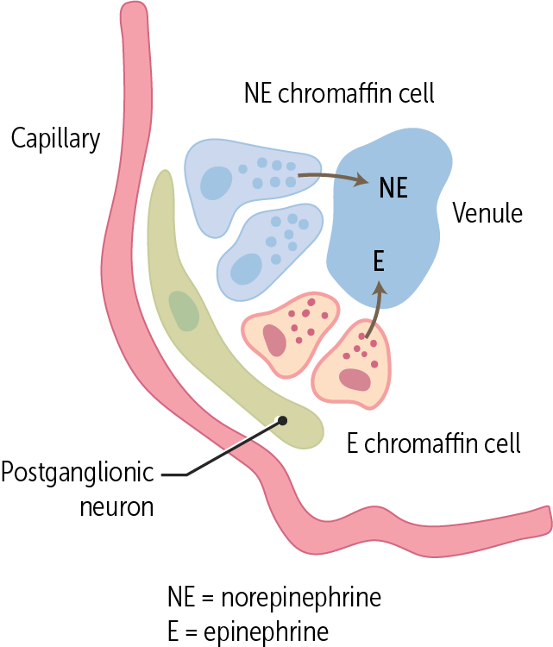

Figure 6

184041

Adrenaline is the driver of the fight-or-flight response during stressful situations—when released into circulation, it increases blood flow to muscles, causes pupil dilation, and increases blood sugar, allowing a person to be ready to respond to stressful situations.

Q: What are the two main hormones secreted by the adrenal medulla?

A: Epinephrine and norepinephrine

Thinking back to PN, what other possibilities do you discuss that could explain her symptoms?

You and PN both know that her hypertension may be due to high levels of glucocorticoids because of the ingested drug. Glucocorticoids serve an important role in maintaining blood pressure, but high levels can cause high blood pressure. She will see her clinician to consider a dose adjustment or addition of an antihypertensive medication to her regimen.

Summary

* The adrenal glands are retroperitoneal glands located on the superior aspect of each kidney but are separated from the kidneys by the renal capsule.
* The adrenal glands are supplied by the superior, middle, and inferior adrenal arteries.
* An adrenal gland is made up of two major regions: the adrenal cortex and the adrenal medulla.
* The three major divisions of the adrenal cortex are the zona glomerulosa, which makes mineralocorticoids; the zona fasciculata, which makes glucocorticoids; and the zona reticularis, which makes androgens.
* The adrenal medulla makes the catecholamines epinephrine and norepinephrine.

Review Questions

1. How does venous drainage differ between the right and left adrenal gland?

1. The venous drainage from the adrenal glands does not differ between sides.
2. The venous drainage from the right adrenal gland empties directly into the hepatic vein; the left adrenal gland empties into the inferior vena cava.
3. The venous drainage of the right adrenal gland empties directly into the inferior vena cava; the left adrenal gland empties into the hepatic vein.
4. The venous drainage of the right adrenal gland empties directly into the inferior vena cava; the left adrenal gland empties into the left renal vein.
5. The venous drainage of the right adrenal gland empties directly into the right renal vein; the left adrenal gland empties into the inferior vena cava.

2. What are the major subdivisions of the adrenal cortex in order of outermost to innermost?

1. Zona fasciculata, zona reticularis, and zona follicularis
2. Zona glomerulosa, zona fasciculata, and zona reticularis
3. Zona medullaris, zona fasciculata, and zona reticularis
4. Zona medullaris, zona glomerulosa, and zona fasciculata
5. Zona reticularis, zona fasciculata, and zona follicularis

3. What area of the adrenal gland synthesizes and secretes cortisol?

1. Zona fasciculata
2. Zona glomerulosa
3. Zona medullaris
4. Zona reticularis

Answers

1. The correct answer is that the venous drainage of the of the right adrenal gland empties directly into the inferior vena cava, and the left adrenal gland empties into the left renal vein (D). The venous drainage between the adrenal glands do differ (A). The right adrenal gland does not empty into the hepatic vein (B), nor does the left adrenal gland (C). The right adrenal gland does not empty into the right renal vein, and the left adrenal gland does not empty into the inferior vena cava; it is the opposite (E).

2. The correct answer is zona glomerulosa, zona fasciculata, and zona reticularis (B). The outmost layer of adrenal cortex is the zona glomerulosa, the middle layer is the fasciculate, and the inner most layer is the zona reticularis. There is no zona follicularis (A, E). The zona medullaris also does not exist (C, D). The adrenal medulla is the other major area of the adrenal gland.

3. The correct answer is zona fasciculata (A). The zona fasciculata synthesizes and secretes cortisol in response to ACTH stimulation from the anterior pituitary gland. The zona glomerulosa (B) secretes mineralocorticoids such as aldosterone in response to renin-angiotensin stimulation. There is no zona medullaris (C), but the adrenal medulla is the inner most layer of the adrenal gland that secretes catecholamines such as epinephrine and norepinephrine. The zona reticularis (D) secretes sex androgens in response to ACTH stimulation from the anterior pituitary.